


Serial Bus Smart Actuator
SCS15 User manual

revise history
date | Version | update content
2016.8.19 | V1.01 | 1. Corrections  2. Increase the run speed control parameters
2016.12.21 | V1.02 | Delete the contents of the communication protocol

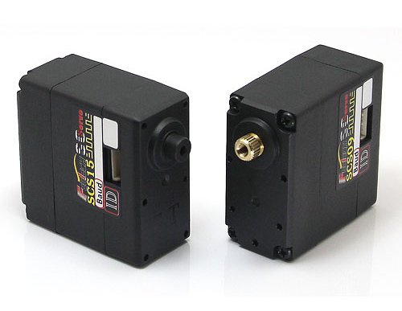

Chapter 1 Overview of Parts

1.1 Product Features
SCS15 serial bus intelligent servo set motor, servo drive, serial bus communication interface and sensor as one of the integrated servo, mainly for micro-robot joints, wheels, track drive, can also be used for other simple location control occasions.
SCS15The features are as follows:

- High torque: 15Kg.cm
- Wide voltage range power supply
- DC 6V ~ 9V
- Resolution 0.19 °
- Dual-axis mounting, suitable for mounting on robotic joints
- High precision all-metal gear set, double ball bearing
- Dual connection port is easy to group chrysanthemum wiring
- Position servo control mode rotation range 0-200 °
- Can be set to motor mode full rotation, open loop speed
- The bus connection theory can be connected in series with 253 ID numbers
- Communication baud rate up to 1M
- 0.25KHz servo update rate
- Using serial bus SCS communication protocol
- With position, temperature, speed, voltage feedback

1.2 structure size
- 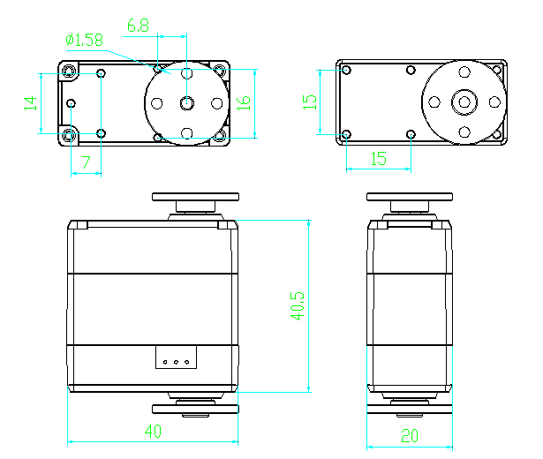

1.3 Electrical connections
- 1.3.1 Pin definition
- SCS15 serial bus intelligent servo electrical interface as shown below, two sets of pins to define a consistent terminal can be connected to the steering gear one by one.
- 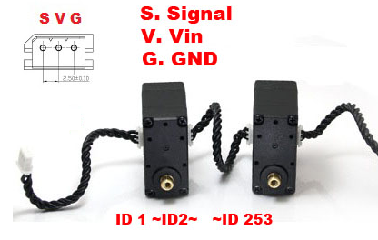
- 1.3.2 Servo communication mode
- SCS15 uses asynchronous serial bus communication, the theory can connect up to 253 robot steering gear. Each steering gear can be set to a different node address, multiple steering gear can be unified control can also be a single independent control.
- SCS15 communication instruction set is open, through the asynchronous serial interface with the user's host computer (controller or PC) communication, you can set its parameters, function control. The SCS15 can be set to motor control mode or position control mode by sending commands via the asynchronous serial interface. In the motor control mode, the SCS15 can be used as a DC gear motor, and the speed is adjustable. In the position control mode, the SCS15 has a range of 0 to 200 °, with high accuracy in position control and variable speed control.
- As long as the protocol half-duplex UART asynchronous serial interface can communicate with the SCS15, the SCS15 for a variety of control. There are two main forms:
- Mode 1: Control the SCS15 via SCM-1 and PC
- PC opportunity to identify SCM-1 as a serial device (driver normal installation), the host computer software through the serial port issued in accordance with the protocol format of the data packet, the SCM-1 forwarded to the SCS15. The SCS15 executes the instruction of the packet and returns the response packet. SCServoDebug.exe is the recommended debugging software, you can also provide the protocol according to the manual design of dedicated PC-side software.

- 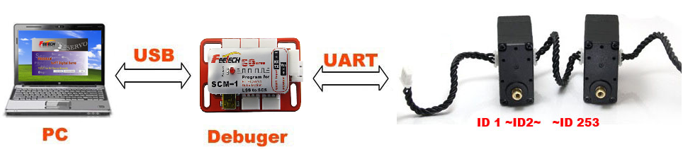
- Mode 2: Control the SCS15 with a dedicated controller
- Mode 1 can quickly and easily debug and control the SCS series serial bus intelligent steering gear, modify a variety of performance and function parameters. However, this way can not be separated from the PC, can not be added as a sensor to build independent control of the robot. If you can design a dedicated controller or use a controller such as Arduino Universal Controller, through the controller's UART port control steering gear, 1.3.3 section gives the controller UART interface signal conversion schematic diagram, you can design their own controller The

- 1.3.3 UART interface schematic
- SCS15 serial bus intelligent servo to achieve half-duplex asynchronous serial bus communication, communication speed up to 1Mbps, and the interface is simple, the agreement streamlined.
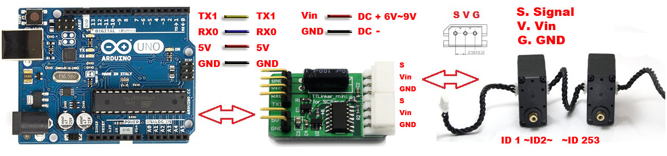
- In your own controller, the UART interface for communication with SCS15 can be processed as shown in the following figure.
- 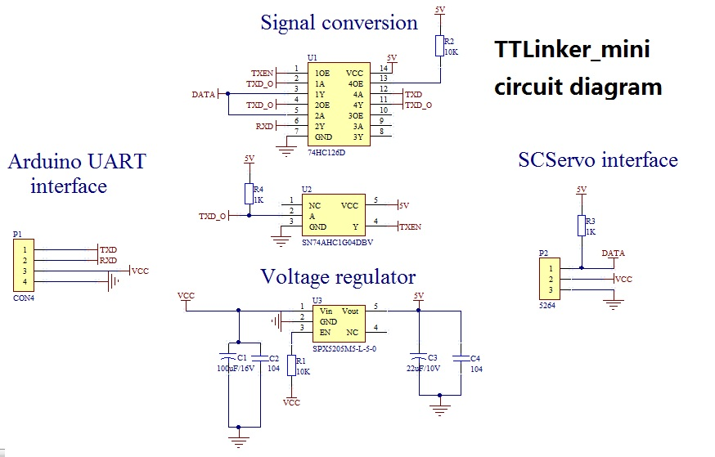

Chapter 2 Memory Control Table

2.1 ERROR Current state
- The response packet contains the current state ERROR of the servo. If the current status of the servo is not normal, it will be reflected by this byte. The information of each representative is as follows：
- BIT | - name | - detailed
- BIT7 | - 0 | - ---
- BIT6 | - 0 | - ---
- BIT5 | - overload | - Position mode run when the output torque is less than the load set to 1
- BIT4 | - 0 | - ---
- BIT3 | - 0 | - ---
- BIT2 | - overheat | - The temperature exceeds the specified range
- BIT1 | - 0 | - ---
- BIT0 | - Overvoltage and undervoltage | - The voltage exceeds the specified range
- If ERROR is 0, the steering gear has no error message.

2.2 Memory control table
- The robot's own servo information and control parameters form a table that is stored in its control chip RAM and EEPROM area. We can modify the contents of the table in real time, you can achieve the purpose of real-time control of the steering gear. This table is called a memory control table, as follows:
- address | - Command item | - Read and write | - Initial value | - Storage area
- 0（0x00） | - -- | - -- | - -- | - EEPROM
- 1（0x01） | - -- | - -- | - -- | - EEPROM
- 2（0x02） | - -- | - -- | - -- | - EEPROM
- 3（0x03） | - Software version（H） | - read | - -- | - EEPROM
- 4（0x02） | - Software version（L） | - read | - -- | - EEPROM
- 5（0x05） | - ID | - Read / write | - 00（0x00） | - EEPROM
- 6（0x06） | - Baud rate | - Read / write | - 00（0x00） | - EEPROM
- 7（0x07） | - Return delay time | - Read / write | - 00（0x00） | - EEPROM
- 8（0x08） | - Response status level | - Read / write | - 01（0x01） | - EEPROM
- 9（0x09） | - Minimum angle limit（H） | - Read / write | - 00（0x00） | - EEPROM
- 10（0x0A） | - Minimum angle limit（L） | - Read / write | - 00（0x00） | - EEPROM
- 11（0x0B） | - Maximum angle limit（H） | - Read / write | - 03（0x03） | - EEPROM
- 12（0x0C） | - Maximum angle limit（L） | - Read / write | - 255（0xFF） | - EEPROM
- 13（0x0D） | - Maximum temperature limit | - Read / write | - 80（0x50） | - EEPROM
- 14（0x0E） | - Maximum input voltage | - Read / write | - 250（0xFA） | - EEPROM
- 15（0x0F） | - Minimum input voltage | - Read / write | - 50（0x32） | - EEPROM
- 16（0x10） | - Maximum torque（H） | - Read / write | - 03（0x03） | - EEPROM
- 17（0x11） | - Maximum torque（L） | - Read / write | - 255（0xFF） | - EEPROM
- 18（0x12） | - High pressure flag | - Read / write | - 00（0x00） | - EEPROM
- 19（0x13） | - Unload conditions | - Read / write | - 37（0x25） | - EEPROM
- 20（0x14） | - LED Alarm condition | - Read / write | - 37（0x25） | - EEPROM
- 21（0x15） | - P | - Read / write | - 15（0x0F） | - EEPROM
- 22（0x16） | - D | - Read / write | - 00（0x00） | - EEPROM
- 23（0x17） | - I | - Read / write | - 00（0x00） | - EEPROM
- 24（0x18） | - Minimal PWM（H） | - Read / write | - 00（0x00） | - EEPROM
- 25（0x19） | - Minimal PWM（L） | - Read / write | - 00（0x00） | - EEPROM
- 26（0x1A） | - Clockwise sensitive area | - Read / write | - 02（0x02） | - EEPROM
- 27（0x1B） | - Counterclockwise insensitive area | - Read / write | - 02（0x02） | - EEPROM
- 28（0x1C） | - Integral limit（L） | - Read / write | - 00（0x00） | - EEPROM
- 29（0x1D） | - Integral limit（H） | - Read / write | - 00（0x00） | - EEPROM
- 30（0x1E） | - Differential sampling coefficient | - Read / write | - 00（0x00） | - EEPROM
- 31--39 | - -- | - -- | - -- | - EEPROM
- 40（0x28） | - Torque switch | - Read / write | - 00（0x00） | - RAM
- 41（0x29） | - -- | - -- | - -- | - RAM
- 42（0x2A） | - target location（H） | - Read / write | - -- | - RAM
- 43（0x2B） | - target location（L） | - Read / write | - -- | - RAM
- 44（0x2C） | - operation hours（H） | - Read / write | - 00（0x00） | - RAM
- 45（0x2D） | - operation hours（L） | - Read / write | - 00（0x00） | - RAM
- 46（0x2E） | - Running speed（H） | - Read / write | - 00（0x00） | - RAM
- 47（0x2F） | - Running speed（L） | - Read / write | - 00（0x00） | - RAM
- 48（0x30） | - Lock mark | - Read / write | - 00（0x00） | - RAM
- 49--55 | - -- | - -- | - -- | - RAM
- 56（0x38） | - current location（H） | - read | - ？ | - RAM
- 57（0x39） | - current location（L） | - read | - ？ | - RAM
- 58（0x3A） | - Current speed（H） | - read | - ？ | - RAM
- 59（0x3B） | - Current speed（L） | - read | - ？ | - RAM
- 60（0x3C） | - Current load（H） | - read | - ？ | - RAM
- 61（0x3D） | - Current load（L） | - read | - ？ | - RAM
- 62（0x3E） | - Current voltage | - read | - ？ | - RAM
- 63（0x3F） | - Current temperature | - read | - ？ | - RAM
- 64（0x40） | - REG WRITE标志 | - read | - 00（0x00） | - RAM
- If the control parameters are "L", "H" of the order, the range is 0x00-0x3FF; parameters only one byte of the order, the range is 0x00—0xFE。
- Save the parameters in the RAM will not save after the power, save the parameters in the EEPROM, power can be saved. "-" indicates that the parameter can not be modified.
- Described as follows:
- 0x06:
- Address 0x06 defaults to 0, the baud rate is 1M, the table can be changed by the table to the baud rate required by the user, the other baud rate will be restored to 1M. The baud rate and the corresponding calculated parameters are as follows:
- Address6 | - Hex | - Actual baud rate | - Target baud rate | - 误差
- 0 | - 0x00 | - 1000000.0 | - 1000000.0 | - 0.000%
- 1 | - 0x01 | - 500000.0 | - 500000.0 | - 0.000%
- 2 | - 0x02 | - 250000.0 | - 250000.0 | - 0.000%
- 3 | - 0x03 | - 128000.0 | - 128000.0 | - 0.000%
- 4 | - 0x04 | - 115107.9 | - 115200 | - 0.079%
- 5 | - 0x05 | - 76923.0 | - 76800 | - -0.160%
- 6 | - 0x06 | - 57553.9 | - 57600 | - 0.008%
- 7 | - 0x07 | - 38461.5 | - 38400 | - -0.160%
- 0x07:
- Set the return delay time, that is, when the servo received a need to answer the instructions, how long delay can be set by you. Time range: Parameter (0 ~ 254) * 2US, if parameter 250, that is 500us after the answer; but the parameter is 0, that the shortest time to answer.
- 0x08:
- Response level, set the servo to receive data after the return data.
- Address 16 | - Returns the response packet
- 0 | - In addition to the read command and the PING instruction other instructions do not return the response packet
- 1 | - Returns the response packet for all instructions
- 0x09～0x0C:
- Set the angle range of the servo to run, the minimum angle limit ≤ target angle value ≤ the maximum angle limit value.
- Note that the minimum angle limit must be less than the maximum angle limit. If the target angle value exceeds the range, it is equal to the limit value.
- 0x0D
- The maximum operating temperature, such as set to 80, the maximum temperature of 80 degrees, set the accuracy of 1 degree
- 0x0E
- The maximum operating voltage, such as high for the 85 maximum operating voltage of 8.5V, set the accuracy of 0.1V
- 0x0F
- The minimum operating voltage, such as the high set to 45 the minimum operating voltage of 4.5V, set the accuracy of 0.1V
- 0x10～0x11
- Set the maximum output torque of the servo. 0X03FF corresponds to the maximum output torque of SCS15.
- 0x13:
- Set the unload condition / LED alarm condition.
- BIT | - Features
- BIT7 | - --
- BIT6 | - --
- BIT5 | - If set to 1, the load reduction / LED alarm is reduced when an overload occurs
- BIT4 | - --
- BIT3 | - --
- BIT2 | - If set to 1, unloading torque / LED alarm when overheating occurs
- BIT1 | - --
- BIT0 | - If set to 1, the torque / LED alarm is unloaded when the voltage range is exceeded
- If the above occurs at the same time, follow the principle of logic or. LED alarm condition (0X14) is set to 0 to turn off the LED, otherwise turn on the LED.
- 0x1A～0x1B:
- Position closed loop dead zone size, clockwise and counterclockwise are set to 1 dead zone large about 0.38 degrees
- 0x28:
- Torque output switch: "1" on, "0" off.
- 0x2A～0x2B:
- Target location, range 0x0000-0x03FF, 0x0000 corresponds to 0 degrees, 0x03FF corresponds to 200 degrees, deviation of ± 2%.
- 0x2C～0x31:
- Set the time and speed of the servo to the target position (the speed parameter is longer than the time parameter, and the time and speed parameters are written, the speed parameter is selected as the control parameter), the time parameter is in milliseconds, the speed parameter is (0.19 Degrees / sec) such as 1000 speed (1000 * 0.19) degrees / second. When set to 0, the maximum speed corresponding to SCS15 is 62RPM.
- 0x30：
- Lock function bit. If this bit is set to 0 to lock the lock, the EEPROM area parameter can be saved.
- Note that the lock function bit is set to 0, SCS15 write speed will slow, frequent EEPROM area parameters to write operation will affect the SCS15 life.
- 0x40：
- If the REG WRITE instruction is pending, it is displayed as 1 and is displayed as 0 when the REG WRITE instruction is executed.

2.3 Motor speed control mode
- SCSSeries of robot steering gear can be switched to motor speed mode, can be used for wheels, crawlers and other working on the implementation of the body.
- The minimum angle limit and the maximum angle limit (0x09 ~ 0x0C) are set to 0, give a speed (0x2C ~ 0x2D), the steering gear to motor speed mode to turn up. Speed has the size and direction of control, as shown in the following table:
- BIT | - 11~15 | - 10 | - 9 | - 8 | - 7 | - 6 | - 5 | - 4 | - 3 | - 2 | - 1 | - 0
- VALUE | - 0 | - 0/1 | - SPEED VALUE
- Address 0x2C ~ 0x2D: BIT10 is the direction of the bit, 0 counterclockwise rotation, 1 clockwise rotation. BIT0 ~ BIT9 is the size.

